v.
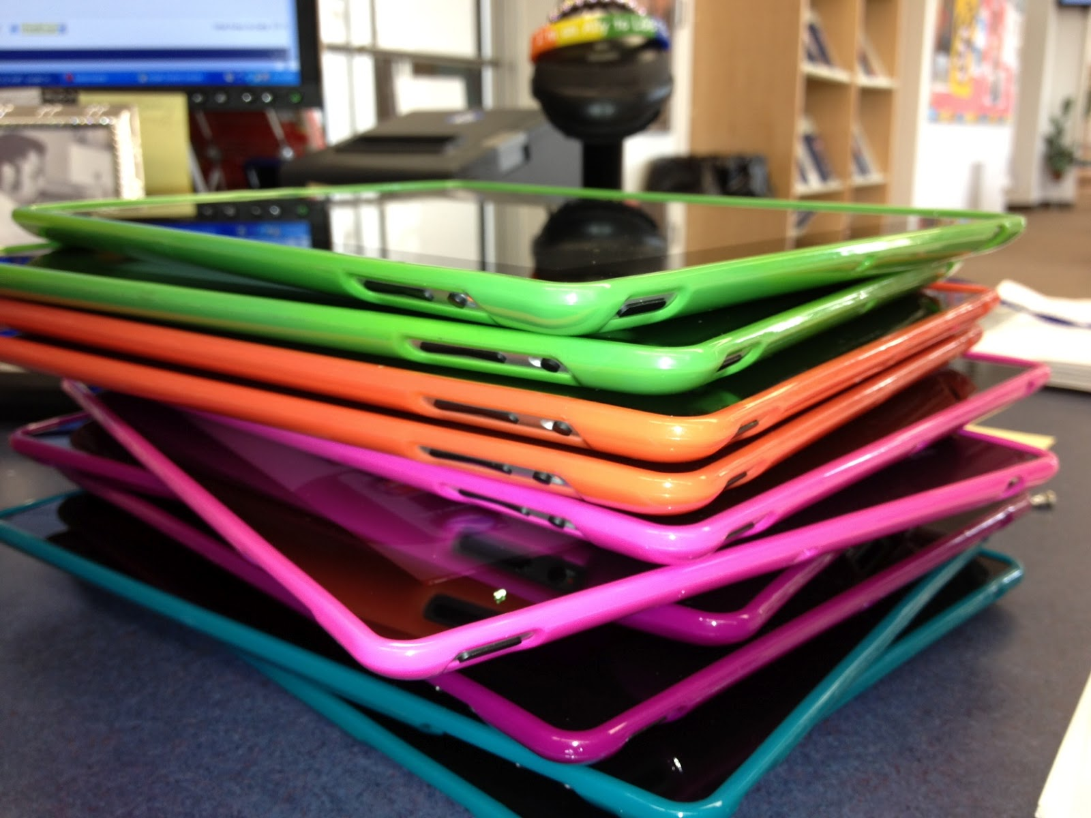

iPad

PARENT - STUDENT HANDBOOK
GLPI Student iPad User Agreement

Student enrolled at Grace Leadership Preparatory Institute will be provided with an Apple iPad for the purposes of facilitating education. Students will be assigned an iPad for 2017-2018 school year, for use in class/school. Parents/guardians can also pay an iPad Rental fee of $300.00, which allows their child/ren to take the iPad home. iPad must be returned upon a student withdrawing from the school, and or at the end of 2017/2018 school year. GLPI retains all ownership rights of the iPad.

Student and Parent Expectations

- Read the iPad Parent-Student Handbook and abide by iPad and technology user agreements.
- Read and understand the Technology Acceptable Use Policy as found in the Grace Leadership Preparatory Institute Parent – Student Handbook, including consequences for failure to comply with the technology user agreement.
- Bring the iPad to school every day. iPad are provided to enhance the educational experience at Grace Leadership Preparatory Institute. (Rental iPad)
- Bring the iPad to school fully charged. No recharging at school. (Rental iPad)

- Do not leave the iPad unattended except when approved by a teacher and stored in a safe, secure location. iPad found unattended in a public space will be brought to the Technology Department. An incident report will result and the student will be notified. Students are responsible for securing the iPad in their cubicles when not needed for classes or while at lunch.

- Keep the iPad in the Higher Ground case always. The carrying case reduces damage to iPad. When not in use, power down the computer. This will preserve battery power.

- While at school only use the iPad when in a classroom supervised by GLPI
staff. Do not use the iPad in the lunchroom, playground, or hallways. Students will not take the iPad to lunch. Students may not use their iPad during dismissal.

- While away from school, only use the iPad in a location free from food, liquid, and debris. Spilling food or drink on the iPad could cause permanent damage. If a spill occurs, unplug the Chromebook. Drain the fluid out of the Chromebook then bring it to the Technology Department as soon as possible. Use the Chromebook on flat surfaces.
- Do not set objects/books on top of the iPad. Setting heavy objects, like musical instruments, sports equipment, or books, on the iPad may cause severe damage to the screen. The iPad should not be placed under items like pillows or blankets, which may cause the iPad to overheat. Do NOT leave the iPad in a v vehicle where heat or cold will damage the iPad. The
Chromebook should not be transported in a backpack. When open, the iPad should never be carried by the lid.

- Do not delete Internet browser history.

- Do not access inappropriate websites. If the student accidently accesses a website that contains obscene, pornographic or otherwise offensive material, he/she should notify a teacher or the Technology Director as quickly as possible so that such sites can be blocked from further access. This is not merely a request; it is a responsibility.

- Abide by copyright laws. Copyright material is protected by law. Any use of copyright material should be appropriately cited. Check with a member of the GLPI faculty or administration if you have questions about using copyright material or how to cite copyright material. Students may not share files except for school related projects.

- The viewing or playing of games on the iPad is not permitted. This includes gaming components that are embedded in websites. Students will be informed by their teachers as to which websites they may access as part of the curriculum.

- The iPad will be available for inspection by an administrator, teacher, or staff member upon request. The iPad and its contents (including websites visited or content created) will be monitored by St. GLPI staff. Students are responsible for using the iPad in accordance with the school policies always and will be held responsible for inappropriate use, including accessing inappropriate websites or materials, while at school or at home. Students will turn in the iPad to the Technology Department for maintenance when requested. iPad are the property of GLPI and are being loaned to students for educational purposes. When students are logged onto the GLPI network during the school day, the administrative staff can search directories for inappropriate content. At any time, a staff member of GLPI may inspect a student’s iPad.

- Use appropriate and respectful language in all communications. As we encourage students to become life-long learners, we continually stress the need to participate in the school and greater community in a manner reflecting our Christian values. While using an iPad, students must use appropriate and respectful language.

- Do not use the iPad to access social networking sites. Because of security, safety, and content issues associated with social networking sites, students are not permitted, at home or at school, to use the iPad to access social networking sites.

- School email account is for educational purposes only! Students will be issued a school email address to be used in communication with teachers and for retrieving any school issued information. This is the only email that the students may access on the iPad. The use of email during class is prohibited unless authorized by the teacher. School email addresses are not to be given to any websites, companies, or any third parties without the explicit permission of a teacher. Please do not email your child during the school day as students are not permitted to respond. Emailing your child during the school day puts your child in a difficult situation. All emails are randomly checked.

- Do not use or harm another student’s iPad. Students will not loan their assigned
iPad to others. Students will not use or attempt to use another student’s or GLPI
staff member’s subscriptions, logins, files, or personal information. The iPad is assigned to one student for educational purposes and may not be loaned to others, including family members. Passwords and logins should remain confidential. Material on the iPad obtained with logins or passwords is the responsibility of the student.

- Do not deface or otherwise decorate the iPad or the carrying case. Students must handle the iPad with care. The iPad are the property of GLPI and may not be defaced by any student. This includes pen marks, stickers, marring the surface, picking at the keys, glitter, etc. The cases are also property of GLPI. If an iPad or carrying case is defaced, parents will be responsible to replace either iPad or case at current market value.
- Do not attempt to repair, alter, or make additions to the iPad. If any repairs need to be made, the student should bring the iPad to the Technology Department. MAKE NO ATTEMPT to fix the iPad. Unauthorized repairs to the iPad can void its warranty.

- Do not travel with or use the iPad at locations other than home/school without parent’s/guardian’s permission. Rather than set limits on the use of the iPad we are relying on parents to be the best judges of where their child may use the iPad. Ultimately, it is the parents who bear the financial responsibility for damages or loss related to the iPad.
- Report problems and damage immediately to the Technology Department. Theft should be reported to the student’s parents, the police, and the Technology Department within 24 hours.

Warranty

The manufacturer’s warranty covers defects in materials or workmanship that may occur. It does not cover damage because of abuse, neglect, misuse, repair by an unauthorized party, unauthorized modification, extreme environments, power surges, lightning, fire and the like. Damage because of exposure to extreme heat or cold will not be covered under the warranty. This includes damage because of a power surge, so we strongly encourage the use of surge protectors at home. GLPI will provide routine hardware maintenance, but does not provide insurance for theft or loss. Nor is the school responsible for damage resulting from negligence, misuse, or other non-warranty repairs. (or other manufacturer) has the final decision as to whether the damage is caused by “customer abuse” or “ordinary wear and tear.” Examples of items not covered by manufacturer’s warranties include: missing keyboard keys, cracked cases and screens, liquid damage, and damaged power adapters. Students are responsible for theft, loss, or damage because of abuse or neglect.

Other Fees and Expenses

Package and shipment of iPad to manufacturer for repair ($25)
Replacement of damaged screen ($75)
Damaged or lost AC adapter (approx. $30)

Damage caused by abuse, neglect or misuse: 100% of the repair cost including shipping
Damage beyond repair: 100% of replacement cost including shipping
Loss or theft: 100% of replacement cost including shipping

Repair Procedure

Students should follow these steps to address problems with the iPad:

- Request a pass from your homeroom teacher to bring their iPad to the Technology Department between the hours of 7:30 AM and 7:50 AM. No student will be seen by the Technology Department without a pass from their homeroom teacher.

- If there are physical damage parents will be notified of the cost of repair based on the above fees & expenses.

- If not fixable on a short-term basis, arrangements for a replacement may be made, depending on cause of the problem and availability of a replacement. The Technology Department may repair the iPad on site or may send the iPad to the manufacturer for repair(s) covered by warranty.

- Do not seek technical assistance from outside providers. GLPI warranty with the manufacturer could be voided if unauthorized repairs are performed. NO reimbursement for any unauthorized repairs will be made.

iPad Quick Tips

- ALWAYS keep the iPad in the Higher Ground case, even when in use.

- Each night, the iPad must be properly shut down and charged.

- Do not leave your iPad unattended or loan your iPad to anyone.

- Keep liquids and food away from the iPad.

- Organize and maintain files as directed by teachers.

- Report problems to the Technology Department as soon as they occur.

- If an inappropriate internet site is accidentally accessed, exit out and notify an adult immediately.

- Do not scratch, hit, or push on the screen. Do not put heavy objects on the iPad.

- Do not attempt to repair the iPad.

- Do not expose the iPad to extreme temperatures.

- Do not leave the iPad in any vehicle at any time of the year.

Grace Leadership Preparatory Institute iPad Use Agreement

Student
Please read and check () each statement before signing:

- I will not modify or disable the iPad in any way unless instructed by district personnel.
- I will not synch the iPad to any computer or add e-mail accounts OTHER than the student account I am assigned at school.
- I will not take the iPad out of the assigned case.
- I will not take inappropriate pictures or use the internet inappropriately as defined by this Acceptable Use Policy.
- I will report any technical issues to my teacher as soon as possible.
- I will not leave my iPad unattended or have my iPad around food or drink.
- I understand that my absences and my actions may cause for the removal of my iPad privileges (either temporary or long-term)

I understand and will abide by the above iPad User Agreement. I further understand that should I commit any violation; my access privileges may be revoked and school disciplinary action taken.

User’s Full Name: _______________________________ Serial #: ________
User Signature: _________________________________ Date: ___________

Parent or Guardian

Please read and check () each statement before signing:

  - I give my child permission to take his/her designated iPad outside of school.
  - I assume all financial responsibility should my child be deemed responsible for damage to the iPad or charger. I understand that a $5 per day fee will be assessed for every day that my child is late in turning his/her iPad in at the end of the year. Also, I understand that if my child is a senior that he/she may not be eligible to participate in graduation ceremonies if all iPad obligations are not taken care of by the end of the year.
  - My child’s actions may cause for the removal of his/her iPad privileges (either temporary or long-term)
  - As a district-owned device, I understand that my child’s iPad can be searched at any time for improper material or evidence of improper use.

As the parent or guardian of this student, I have read the iPad User Agreement.

Parent or Guardian’s Name (please print:) _________________________________ Parent or Guardian’s Signature: ___________________________________________ Date: ____________________________________

